**Stress Learning Games**

**Iteration 1**

* Team members and roles
  + Hanyang Li (Product Owner)
  + Ping Lu (Scrum Master)
  + Xin Hu (Programmer)
  + Zhiyu Yan (Programmer)
  + Chaoyang Zhu (Game Testing)
  + Yipeng Lu (Game Design and Game Testing)
  + Mufeng Xie (Report Editor)
* Customer meeting data/time/place
  + Mondays 2020 Spring Semester, 1:00 – 2:00 pm, EABA
* Summary
  + The basic process of the playing the game:

Click on “Start Game” botton on the screen and jump to the word guessing page.

There will be a Health Point tape on top of the screen, which represents the time remaining. If the remaining time is less then 10 seconds, the screen will twinkle for three times and turn red. The game will be over if there’s no time remaining.

The hint picture for the word guessing and the input typing blank will be in the middle of the screen. The experience would get increased in a certain scale when the word has been guessed correctly according to the difficulty and the time remaining. When the time is over or 3 times of wrong guessing occurred, the experience would get reduced and the right answer would appear on the screen. No matter what result of this word guessing is, the interface would jump to the next word.

The experience tape is at the bottom, which is initially above zero. Different experience value would represent different title, which has different color of the tape, and different difficulty level of the words, which also affects the maximum allowed time. When the experience tape reaches the maximum amount, it will come to the page showing success; When it reaches zero, the “game over” page would appear. Both of the 2 pages have buttons to turn into the main interface of the game.

Main interface

Start Game

Game over Page

Success page

Word guessing page

EXP reaches max No EXP remaining

EXP changes

* + Video link: TBD
  + GitHub repo: TBD
  + Pivotal Tracker: TBD
* User stories
  + Feature: Given a text hint or a picture hint along with some potential answers, if the user drags the correct word(s) to the text hint or picture hint, then he/she would get some EXP! If the user drags the wrong word(s) to the text hint or picture, he or she would lose EXP and three times the right answer would appear.
* User interface

Drag the correct word to the correct place according to the hint below. The user would get immediate correct or incorrect feedback in the form of words, colors, sound, etc.

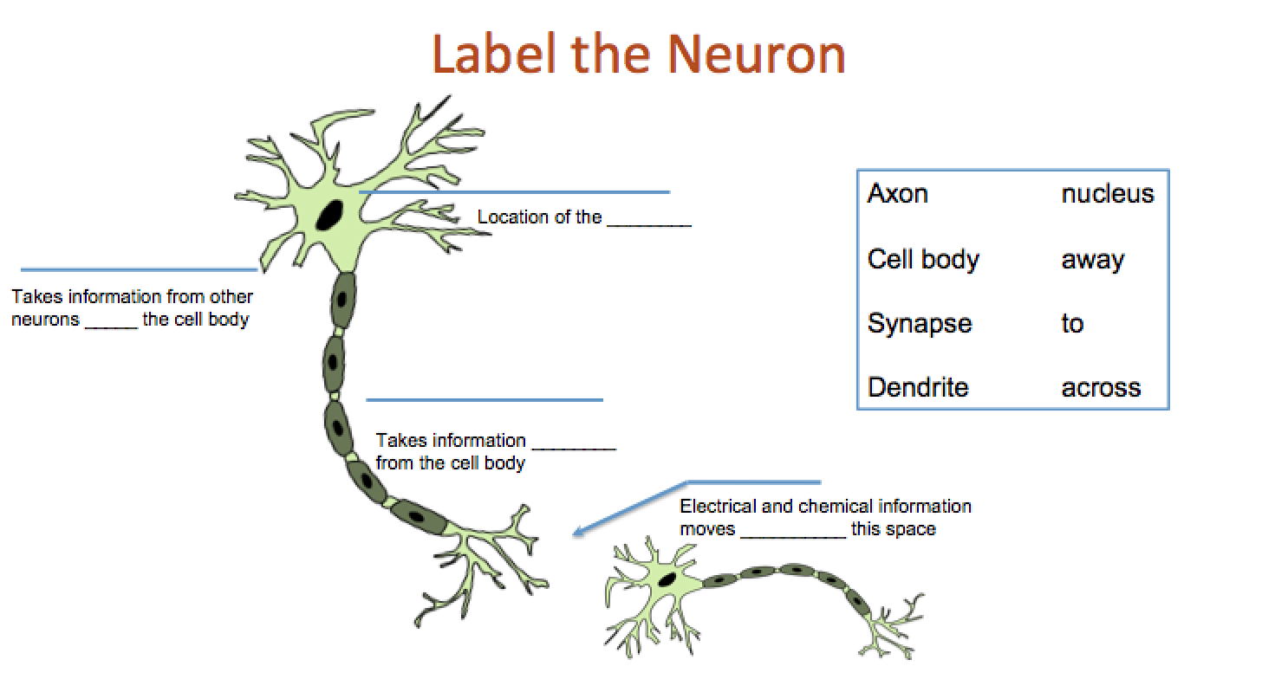

***Figure 1. Label the neuron***